13 Delta Sig Couples Take July 2009 Cruise

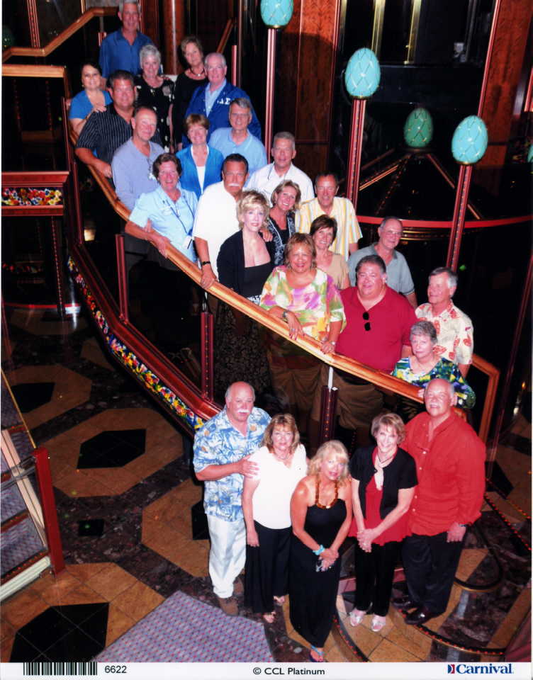
Thirteen Epsilon Rho couples from the ‘60’s and ‘70’s thoroughly enjoyed each others’ company, shipboard activities, and shore excursions to Catalina and Ensenada on a five-day cruise July 20-24, 2009. Officially known as the 3rd Annual Ol’ Guys Adventure, this year’s gathering was expertly planned and carried out by Noel “Bull” Shutt, F’69, with savvy negotiating assistance from Ed “Gunga” Denn, W’70.

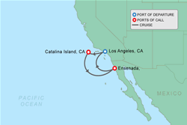
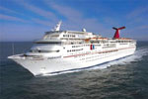

The lucky 13 couples were:

Ted “Fingers” & Lynn Palmer, S’60
Pete “Wacker” Foster and Susan, S’64
Greg “Deuce” & Barb Piers, F’67
Gene “Spanky” & Susie Blazick, W’68
Noel “Bull” & Linda Shutt, F’69
Fernando “Pico” & Rosa Mesquita, W’70
Ed “Gunga” and Nadine Denn, W’70
Mike “Harpo” & Dea Roanhaus, S’70
Jeff “Grobo” & Joanne Weaver, S’70
John “Bambi” & Sandra Buck, F’70
Tom “Woody” & Judi Brooks, W’73
Chris “Yabut” & Carol Patterson, W’73

Ryan & Robert Shutt, Bull and Linda’s sons, braved the voyage with us and were just great company too.

This trip was over-the-top outstanding and more comments by the cruisers are being collected to place here.

